AP CSP Python with CodeX  Algorithms #1 Activity Guide |  | Name:
Robot Code : Solve each problem using the warehouse map and robot code.
1. A program is written for a robot to pick up multiple packages. As the robot drives over a package, the robot picks it up. Following the provided program code, which list shows the packages the robot picks up in the order they are collected?  PROGRAM:  MOVE_FORWARD(3)  ROTATE_LEFT()  MOVE_FORWARD(3)  ROTATE_RIGHT()  MOVE_FORWARD()  Answers:  - 1, 4, 3, 8  - 1, 4, 3, 6  - 1, 4, 3, 9  - 1, 4, 5, 9, 6 | 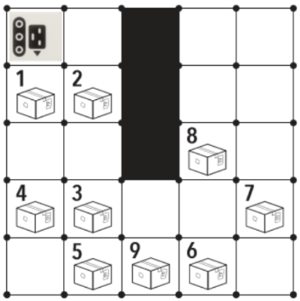
2. This program was designed for only one robot to take their package to chute C6. For which robot is this program written?  PROGRAM:  MOVE_FORWARD()  ROTATE_RIGHT()  MOVE_FORWARD()  ROTATE_RIGHT()  MOVE_FORWARD()  ROTATE_LEFT()  MOVE_FORWARD()  Answers:  - Robot 1  - Robot 2  - Robot 3  - Robot 4 | 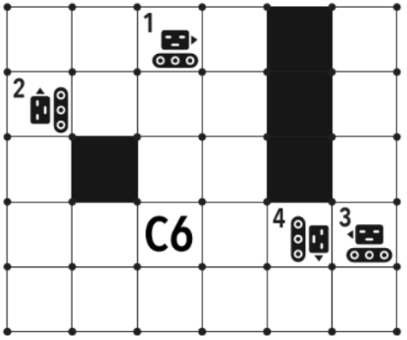
3. A robot has picked up a package that is ready for shipping. Which of the following codes will NOT direct the robot to chute 7C?  Answers:  - MOVE_FORWARD(1)  ROTATE_RIGHT(3)  MOVE_FORWARD(3)  ROTATE_RIGHT(1)  MOVE_FORWARD(1)  - ROTATE_RIGHT(3)  MOVE_FORWARD(1)  ROTATE_RIGHT(1)  MOVE_FORWARD(4)  ROTATE_RIGHT(3)  MOVE_FORWARD(2)  ROTATE_RIGHT(3)  MOVE_FORWARD(2)  - MOVE_FORWARD(4)  ROTATE_RIGHT(1)  MOVE_FORWARD(3)  ROTATE_RIGHT(1)  MOVE_FORWARD(2)  - MOVE_FORWARD(4)  ROTATE_RIGHT(3)  MOVE_FORWARD(3)  ROTATE_RIGHT(3)  MOVE_FORWARD(2) | 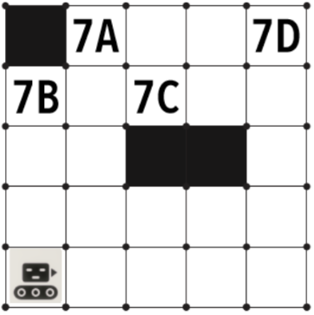
4. Your colleague wrote this code to guide the robot to chute 3B. Unfortunately they made a mistake and swapped the order of two of the lines. Can you correct this error and get the robot to chute 3B?  PROGRAM:  1 MOVE_FORWARD()  2 MOVE_FORWARD()  3 ROTATE_RIGHT()  4 MOVE_FORWARD()  5 ROTATE_LEFT()  6 MOVE_FORWARD()  7 MOVE_FORWARD()  Answers:  - Swap lines 2 and 3  - Swap lines 3 and 4  - Swap lines 4 and 5  - Swap lines 5 and 6 | 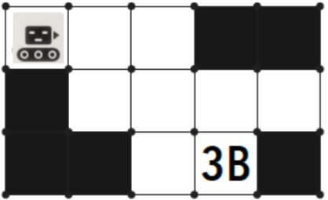
5. There are 8 packages ready to be picked up and taken for delivery. The robot has been programmed to pick up some of these. Which list shows the packages the robot picks up in the order they are collected?  PROGRAM:  MOVE_FORWARD(1)  ROTATE_RIGHT(1)  MOVE_FORWARD(3)  ROTATE_LEFT(3)  MOVE_FORWARD(1)  ROTATE_LEFT(2)  MOVE_FORWARD(2)  Answers:  - 8, 6, 3, 5  - 7, 2, 4, 3  - 7, 2, 4, 1  - 7, 2, 3, 4 | 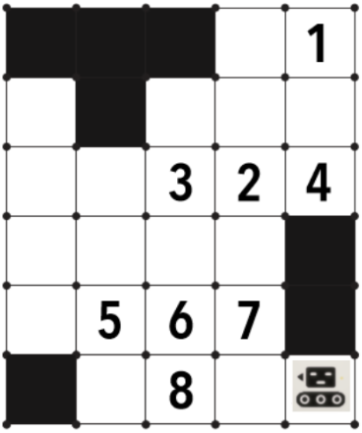
6. An employee wrote the following program, but it does not correctly get the robot to the package (P). Which two lines in the program code need to be switched in order for the robot to correctly navigate the warehouse to get to the package?  PROGRAM:  1 ROTATE_LEFT()  2 ROTATE_LEFT()  3 MOVE_FORWARD()  4 MOVE_FORWARD()  5 MOVE_FORWARD()  6 ROTATE_RIGHT()  7 ROTATE_RIGHT()  8 MOVE_FORWARD()  9 ROTATE_RIGHT()  10 MOVE_FORWARD()  Answers:  - 2 and 6  - 5 and 9  - 4 and 7  - 1 and 3 | 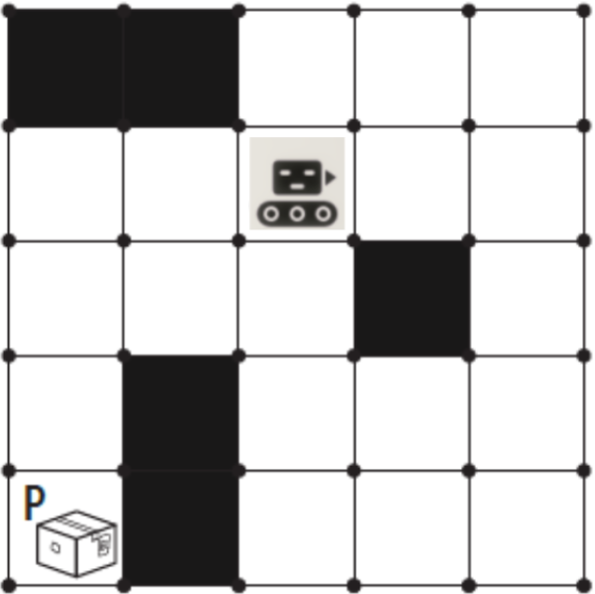
7. A robot has finished his last package delivery for the day and needs to return to the docking station to charge. In which order could the blocks of program code be put together into a larger program so that the robot safely makes it back to the docking station?  Segment A:  ROTATE_RIGHT()  ROTATE_RIGHT()  Segment B:  MOVE_FORWARD()  ROTATE_LEFT()  MOVE_FORWARD()  ROTATE_RIGHT()  Segment C:  MOVE_FORWARD()  MOVE_FORWARD()  Segment D:  ROTATE_LEFT()  Answers:  - D, D, D, C, D, A, C  - D, D, C, D, B, C, A, A, C, B, C, A, B  - A, C, C, D, B, B, C, D, D, D, C  - None of these combinations will take the robot home to the docking station. | 